Computer Science 4442

Assignment 2

Ian Borwick

250950449

[iborwick@uwo.ca](mailto:iborwick@uwo.ca)

Table of Contents

1 2

a) 2

b) 2

c) 2

d) 2

2. 3

a) 3

b) 4

c) 5

3. 6

a) 6

b) 6

c) 7

d) 7

e) 8

f) 9

g) 11

1.

## a)

p(Water = cool|Play = yes) = **1/3**

p(Water = cool|Play = no) =  **0**

## b)

p(Play = yes|Water = warm) = **2/3**

p(Play = no|Water = warm) = **1/3**

## c)

p(Play = yes|Humid = high) = **2/3**

p(Play = yes|Humid = normal) = **1**

## d)

With Laplace smoothing:

p(Water = cool|Play = yes) = **2/5**

p(Water = cool|Play = no) = **1/3**

# 2.

## a)

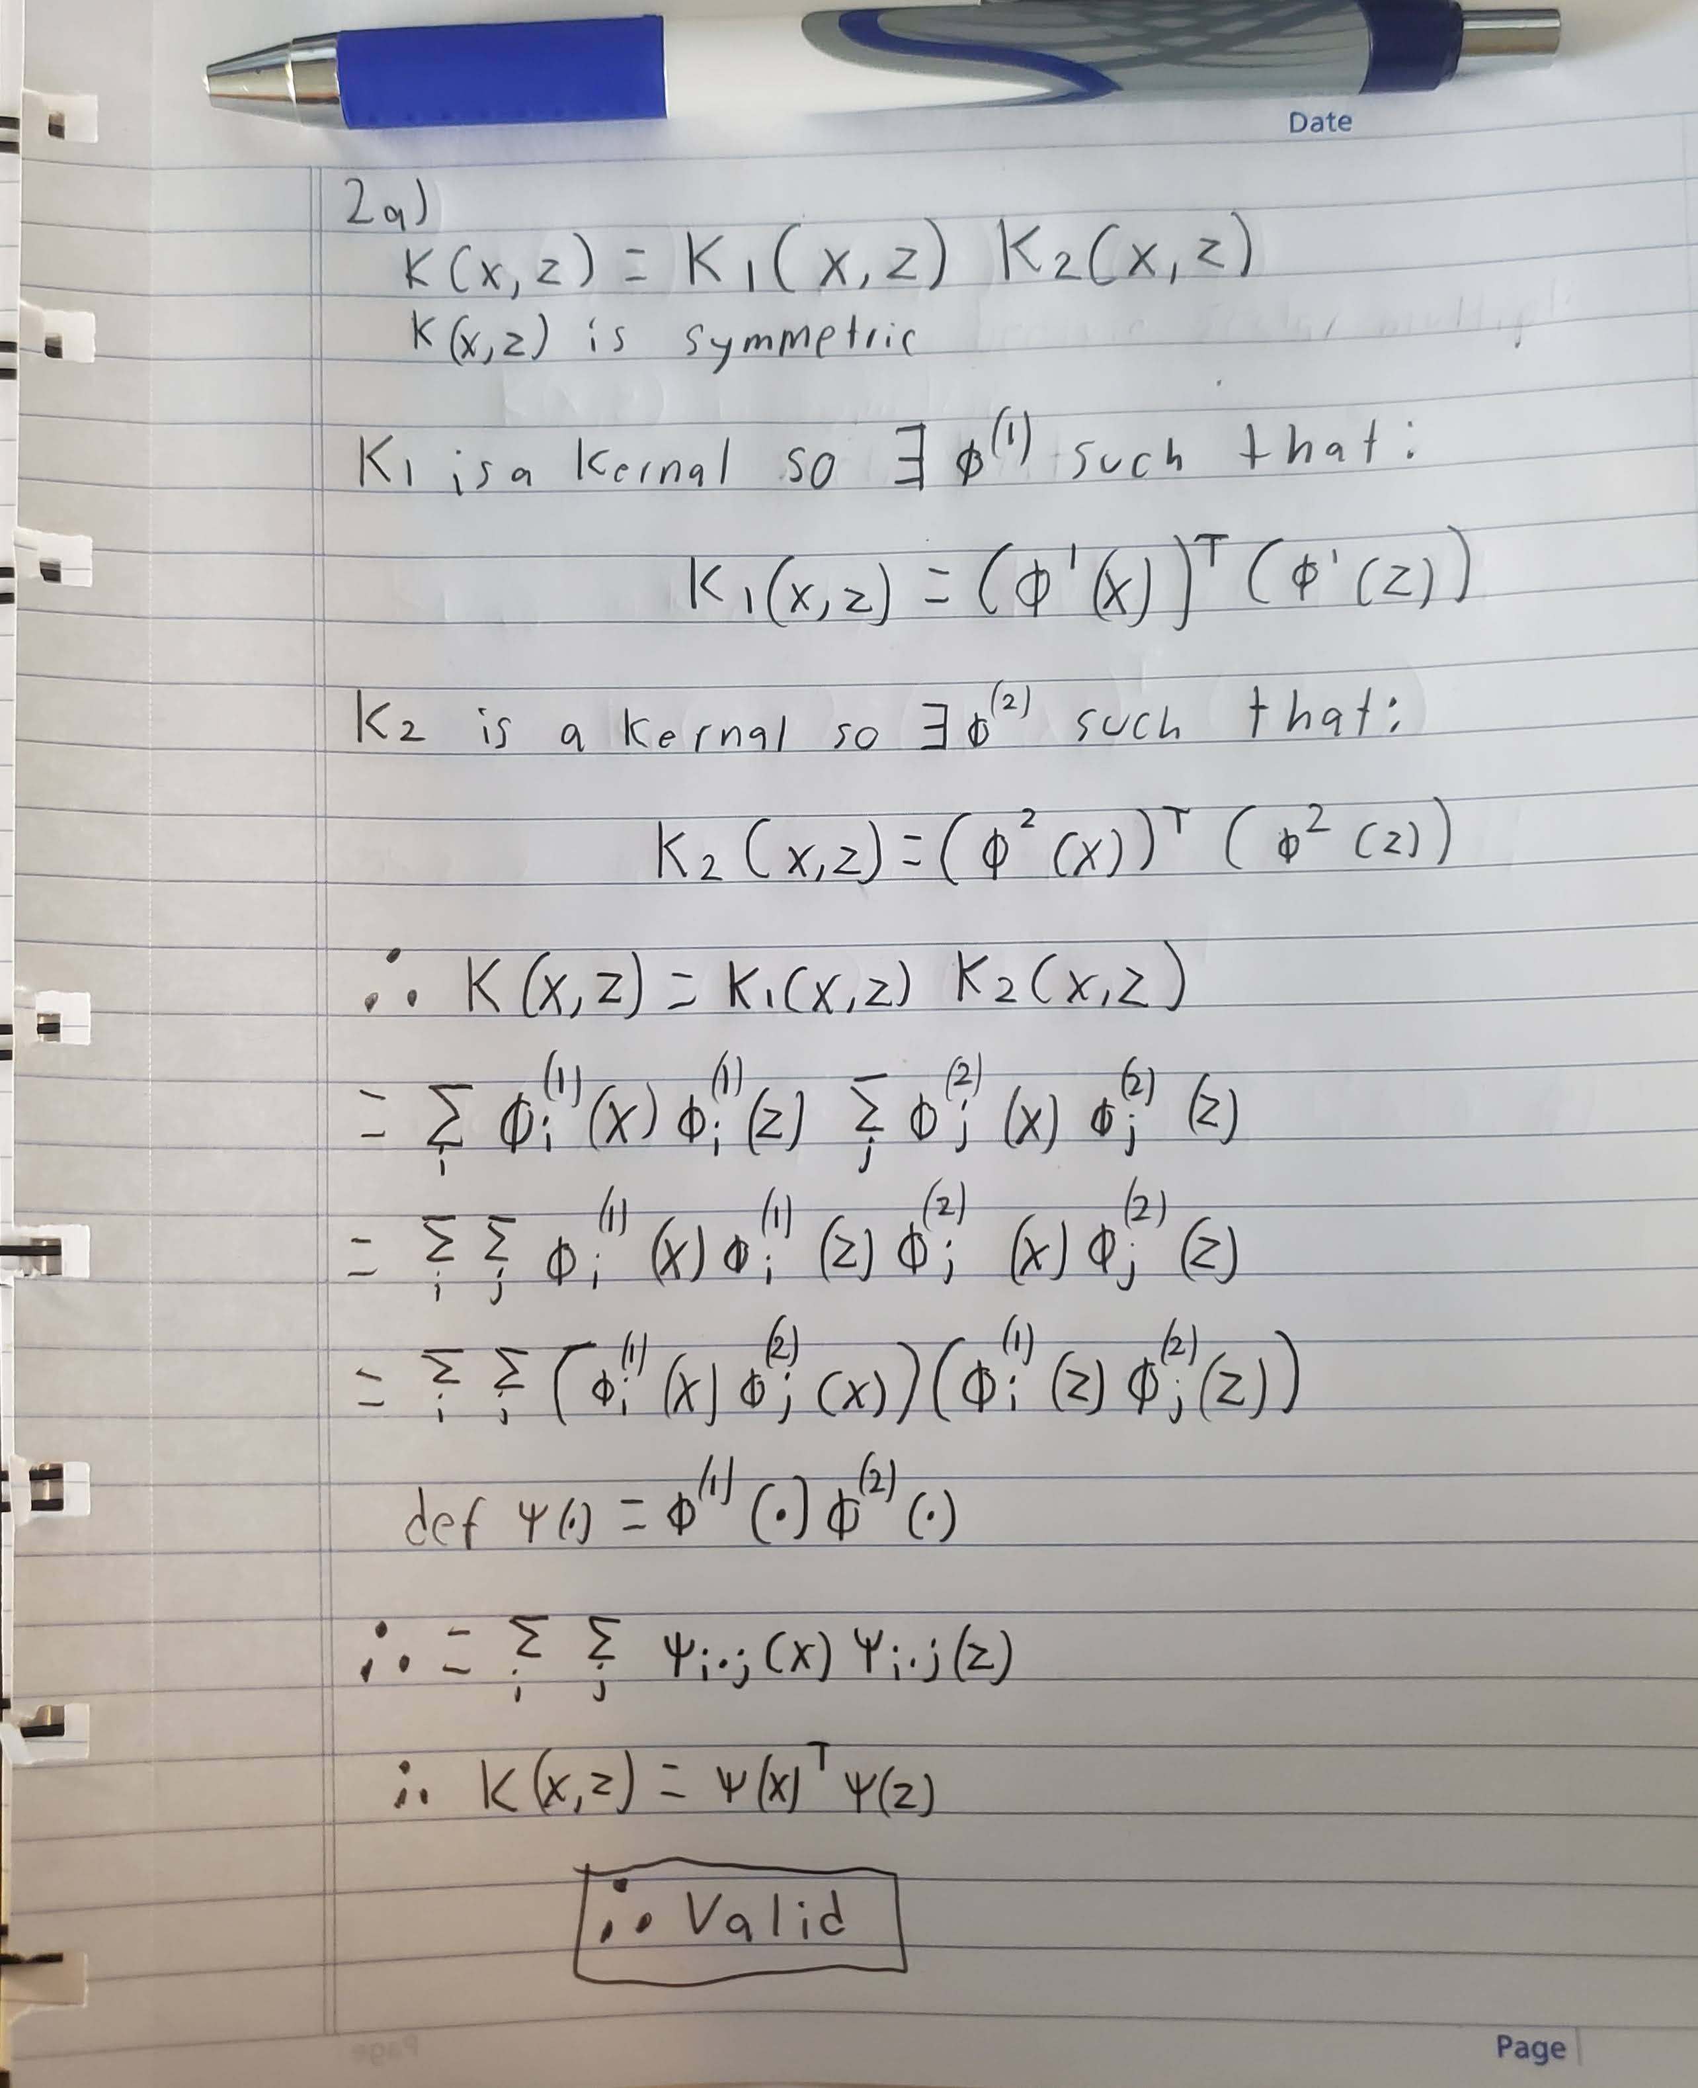

## b)

## c)

# 3.

## a)

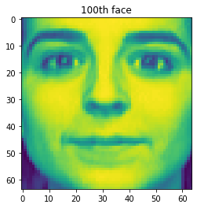

## b)

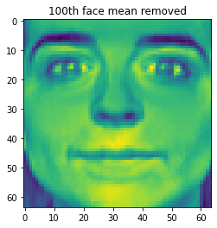

## c)

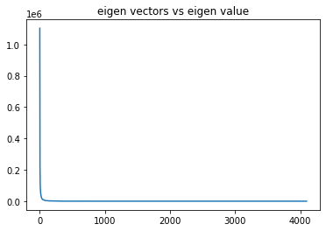

## 

## d)

This means that the null space is nontrivial in other terms the image is slightly compressed as it is of a lower dimension as well this means the matrix is not invertible.

## e)

## 

In order to keep 95% variance, we are required to keep a dimensionality of ~140 meaning we only need to keep ~100 components.

Required Dimensionality: 123

## f)

|  |  |
| --- | --- |
|  |  |
|  |  |
|  |  |

## g)

|  |  |
| --- | --- |
|  |  |
|  |  |
|  |  |
|  |  |